三大类型转换

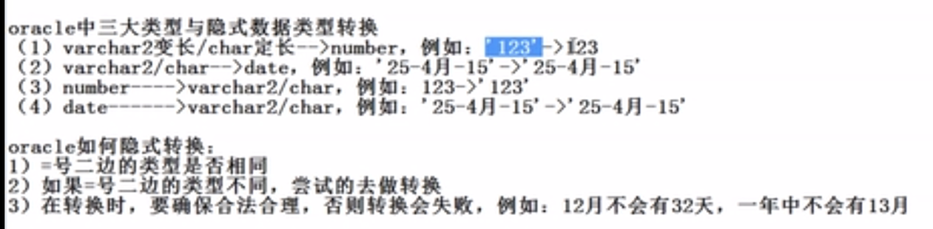



Select * from emp where hiredate=’17-12月-80’;



Select to_char(sysdate,'YYYY”年”-MM”月”-DD”日” day') from dual;



Select to_char(sysdate,'YYYY-MM-DD”今天是” day hh:mm:ss') from dual;



Select to_char(1234,'$9,999') from dual;



Select to_char(1234, 'L9,999') from dual;



Select * from emp where hiredate=to_date('1980年12月17日' ,'yyyy "年"mm "月"dd"日"');



select to_number('123') from dual;

注意：to_number()括号里面的字符串必须全是数字字符，否则报错

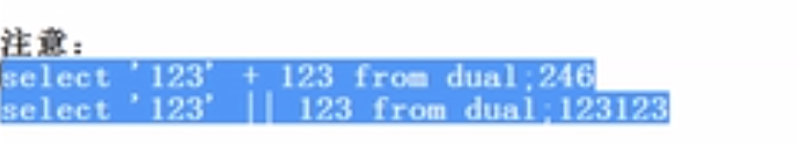

======================================================================

单行函数

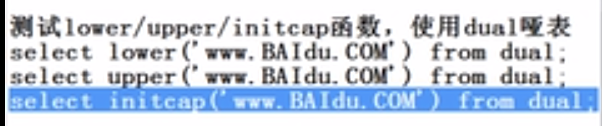

Select lower(‘www.BAIdu.com’) from dual;

Select upper(‘www.BAIdu.com’) from dual;

Select initcap(‘www.BAIdu.com’) from dual; **首字母大写**

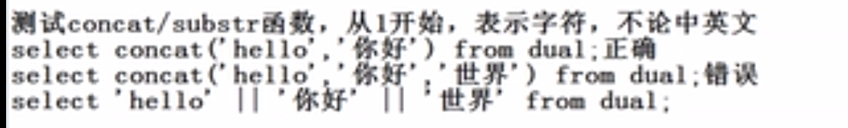

Select concat(‘hello’,’world!!!’) from dual; **注意：concat函数只能连接两个字符串**

Select ‘hello ’ ||’world’ ||’ how are u?’ from dual; 三个以上字符串这样子连接

还可以用嵌套的concat

Select concat(concat(‘hello’,’world!!!’),’ how are you’) from dual;



Select length(‘hello你好啊’) from dual; **9字符数**

Select lengthb(‘hello你好啊’) from dual; **12字节数**

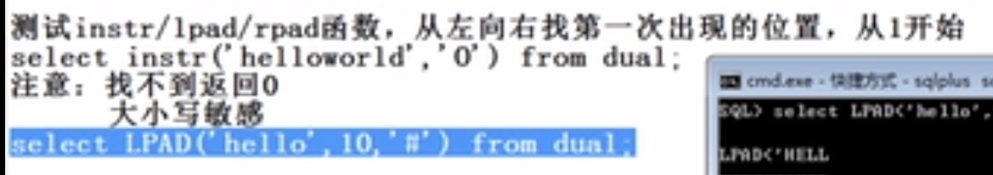

Select instr(‘hello world!!!’,’o’) from dual; **返回5**

**Select lpad(‘hello’,10,’*’) from dual; 返回*****hello，长度不够，左边补\***

**Select lpad(‘hello world’,5,’*’) from dual; 返回hello，字符串长度比需要的长度大，就截取需要的长度的字符串返回**

**Select rpad(‘hello’,10,’*’) from dual; 返回hello *****，长度不够，右边补\***

**Select rpad(‘hello world’,5,’*’) from dual; 返回hello，字符串长度比需要的长度大，就截取需要的长度的字符串返回**



**Select trim(‘o’ from ‘ooheoooollooooooooooo’) from dual; 删除两边的’o’返回heooooll**

**Select replace(‘hello’,’l’,’L’) from dual; 返回heLLo**

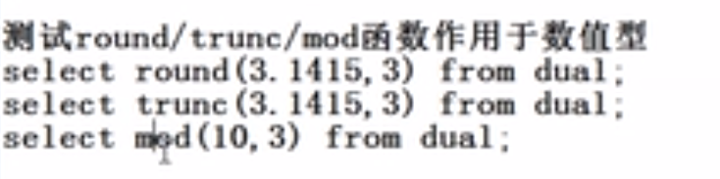

**Select round(3.1415,3) from dual; 返回3.142，有四舍五入功能**

**Select trunk(3.1415,3) from dual; 返回3.141，只是截断，不四舍五入**

**Select mod(10,3) from dual; 10/3取余数，返回1**

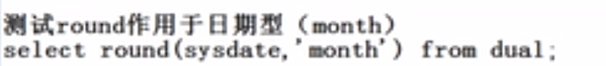

**Select round(sysdate,’month’) from dual; 假设当前日期为29-2月-20，返回1-3月-20**

**Select round(to_date(‘15-2月-20’),’month’) from dual; 返回：1-2月-20**

**Select round(to_date(‘16-2月-20’),’month’) from dual; 返回：1-3月-20**



**Select round(sysdate,’year’) from dual; 假设当前日期为29-2月-20，返回1-1月-20**

**Select round(to_date(‘29-7月-20’),’year’) from dual; 返回：1-1月-21**

**注意Round函数具有四舍五入的功能，**

**year的计算方式：6月一下的算本年，6月以上，算下一年**

**month的计算方式，小于16号，算本月，大于等于16号算下一个月**

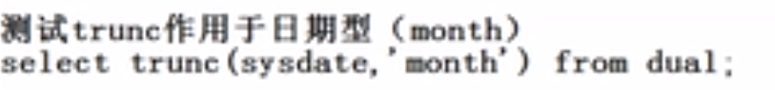

**Select trunk(sysdate,’month’) from dual; 假设当前日期为29-2月-20，返回1-1月-20**

**Select trunc(to_date(‘29-7月-20’),’month’) from dual; 返回1-7月-20**



**Select trunc(sysdate,’year’) from dual; 返回1-1月-20**

**Select trunc(to_date(‘29-7月-20’),’year’) from dual; 返回1-1月-20**

**注意，trunc函数没有四舍五入的功能，使用以上两个例子的结果相同**



**Select sysdate-1 “昨天”,sysdate “今天”,sysdate+1 “明天” from dual;**



**Select ename “员工姓名”,round( sysdate-hiredate,0) “已工作天数” from emp;**

**Select ename “员工姓名”,round( sysdate-hiredate,0) /30 “已工作月数” from emp;**

**Select ename “员工姓名”,round( sysdate-hiredate,0) /30 /12 “已工作年数” from emp;**



**Select months_between(’31-12月-20’,sysdate) from dual;**

**假设当前日期为29-2月-20，返回10**



**Select ename “姓名” ,months_between (sysdate,hiredate ) “精确月工龄” from emp; 大日期在前面，小日期在后面，正数。或者说将来的日期放在前面，现在或过去的日期放在后面**

**Select ename “姓名” ,months_between (hiredate,sysdate ) “精确月工龄” from emp;负数**

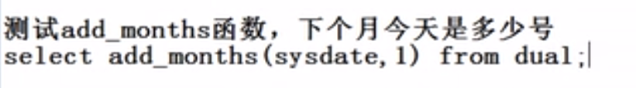

**Select add_months(sysdate,1) from dual;**



**Select add_months(sysdate,-1) from dual;**



**Select next_day(sysdate,'星期三') from dual;**



**Select next_day(next_day(sysdate,'星期三') ,'星期三' ) from dual; 难点**



**Select next_day(next_day(sysdate,'星期三') ,'星期日' ) from dual; 难点**



**Select last_day(sysdate) from dual;**



**Select last_day(sysdate)-1 from dual;**



**Select last_day(add_months(sysdate,1)) from dual;**



**Select last_day(add_months(sysdate,-1)) from dual;**



**=================通用函数和条件判断函数================**

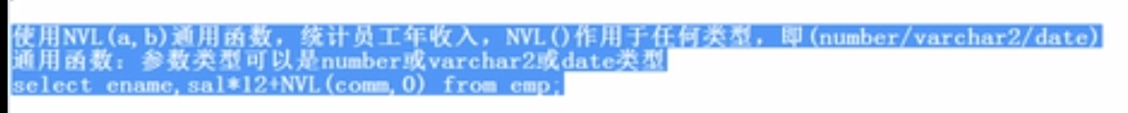

**select ename,sal*12+nvl(comm,0) from emp;**



**select ename,sal*12+nvl2(comm,comm,0) from emp;**



**select nullif(10,'10') from dual；出错，类型不一致**

**select nullif(10,10) from dual；正确，没有任何输出**





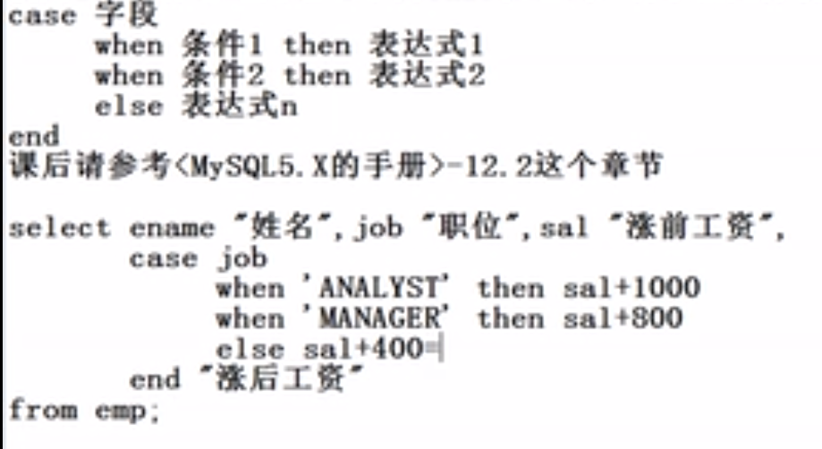

**select ename "姓名",job "职务",sal "涨前工资",**

**case job**

**when 'ANALYST' then sal+1000**

**when 'MANAGER' then sal+800**

**else sal+400**

**end "涨后工资"**

**from emp; (注意，这个sql语句只是在显示的时候加了工资，并没有真真正正增加工资) 难点**

**使用oracle sql 专用语法decode也可以实现以上功能**

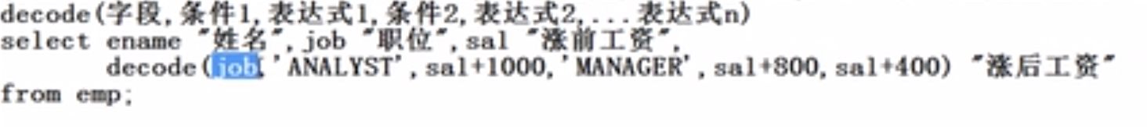

**select ename "姓名",job "职务",sal "涨前工资",**

**decode(job, 'ANALYST' , sal+1000, 'MANAGER' , sal+800,sal+400) "涨后工资"**

**from emp;**

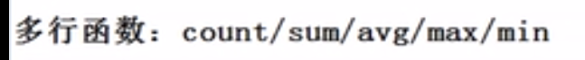

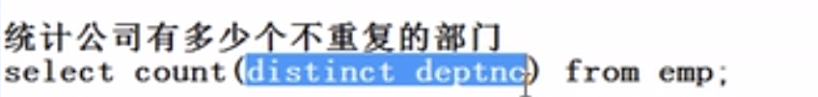

**select count(distinct deptno) from emp; 返回3**





**注意：多行函数不统计null值；**



**select sum(sal) "总工资",round(avg(sal),0) "平均工资" from emp;**

### 查询员工表中的最高工资，最低工资

**select max(sal)"最高工资",min(sal) "最低工资" from emp;**

### 查询员工表中的入职最早，入职最晚

**select min(hiredate)"入职最早",max(hiredate) "入职最晚" from emp;**



**select deptno "部门编号",trunc(avg(sal)) "部门平均工资" from emp group by deptno;**

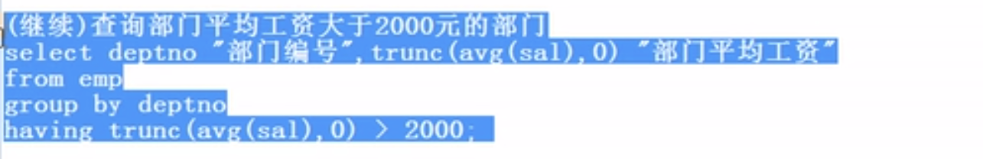

**select deptno "部门编号",trunc(avg(sal)) "部门平均工资" from emp group by deptno having trunc(avg(sal)) > 2000;**

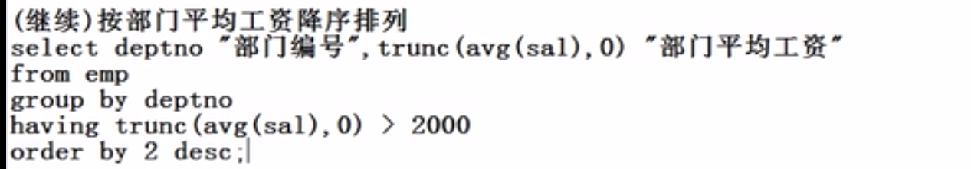 **select deptno "部门编号",trunc(avg(sal)) "部门平均工资" from emp group by deptno having trunc(avg(sal)) > 2000 order by 2 desc;**

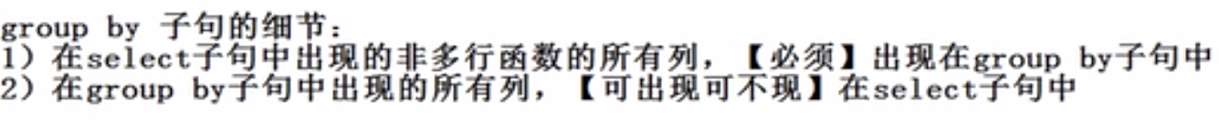

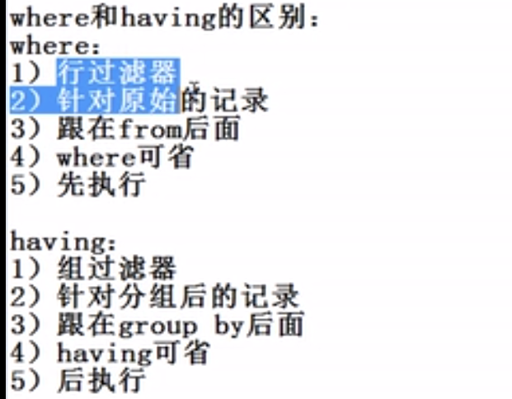

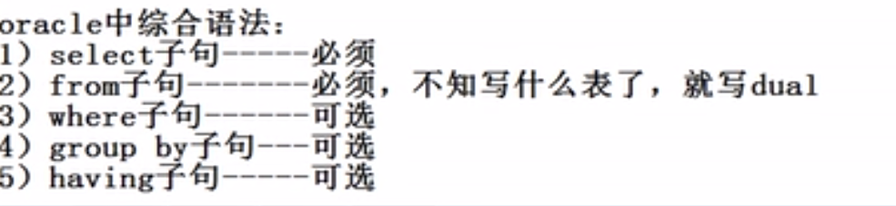

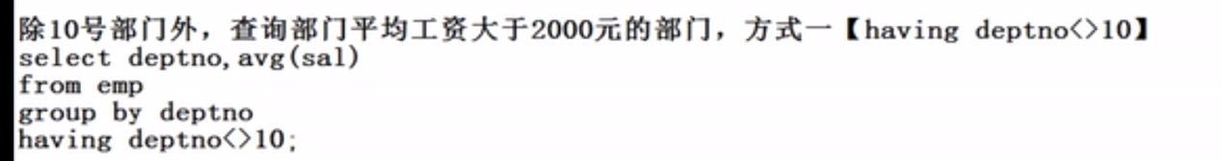 **select deptno,avg(sal) from emp group by deptno having deptno<>10;**

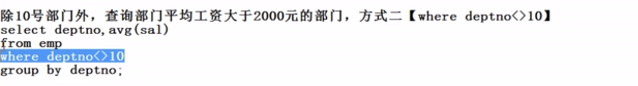 **select deptno,avg(sal) from emp where deptno<>10 group by deptno;**

**建议使用方式2**

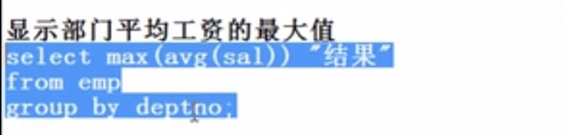

**select max(avg(sal)) "部门平均工资最大值" from emp group by deptno;**